How the lack of colour in landscape photography can change people’s perspectives?

The theme within colour that I have chosen to investigate is how manipulating colour within a photographic landscape can change the way people perceive the photograph.
Colours can make us feel happy or sad… they can make us feel hungry or relaxed. As a photographer, it’s important to understand the psychological effects colours might have on the viewer.
There are several reasons why colours are able to influence how we feel. Leslie Harrington, executive director of The Colour Association of The United States quotes "We react on multiple levels of association with colours -- there are social or culture levels as well as personal relationships with particular colours."
It has also been theorised that people also have an innate reaction to colour. For example, when one looks at red, it can increase the heart rate; it can be for many people a stimulating colour. This has been linked to caveman days were red represented of fire, danger and alarm.
However as a society we have also developed some learned associations with colour, such as red making your heart race since it’s linked with fire trucks and ambulances (in other words, alarm) or yellow having positive association simply because it was the colour of your beloved grandmother’s kitchen. "As you get older, you become much more conscious of those learned reactions than the innate ones," adds Harrington.
Throughout this essay I will be using perspective as a means of expressing the particular attitude a person has towards regarding something; a point of view in order to explore my theme were I will be analysing and comparing the work of Ansel Adams, Charlie Waite, and Galen Rowell.
I will specifically explore how the use of or lack of colour can change the mood and emotion of the viewer and how certain moods and atmospheres can be expressed through colour and the photographic landscape.

Colour within the photographic image has always played a major role in telling a story, whether it’s the sticking use of black and white or intense use of saturated colour it continues to be one of the most important tools in the photographers control that allow him or her to impact the viewer in a very personal way.
Ferenc Berko, a classic photographer who lived during the rise of colour film in the 1930’s was one of the photographers who immediately recognised the potential of colour within photography as an art medium. He saw it as a new way to frame the world, a way to experiment with the subjects he photographed and how they conveyed emotion. John Hedgecoe, another photographer who lived during this time, was another example of those who preferred colour to black and white. In his a book entitled ‘The Art of Colour Photography’ he explains the importance of understanding the "special and often subtle relationships between different colours". He also describes the psychological and emotional power that colour can have on the viewer since “certain colours can make people feel a certain way”.

The first photographer I will investigate is Ansel Adams. Adams was a renowned American photographer and environmentalist who primarily used large-format cameras because of their high resolution which helped ensure sharpness in his images. His black-and-white photographs of the American West, especially Yosemite National Park have been widely reproduced on calendars, posters, and in books.
Adams, Ansel (Feb. 20 1902 — Apr. 22, 1984), photographer and environmentalist, was born in San Francisco, California, the son of Charles Hitchcock Adams, a businessman, and Olive Bray. The grandson of a wealthy timber baron, Adams grew up in a house set amid the sand dunes of the Golden Gate. If Adams’s love of nature was nurtured in the Golden Gate, his life was, in his words, “coloured and modulated by the great earth gesture” of the Yosemite Sierra. He spent substantial time there every year from 1916 until his death. From his first visit, Adams was transfixed and transformed. He began using the Kodak No. 1 Box Brownie his parents had given him. He hiked, climbed, and explored, gaining self-esteem and self-confidence. Adams’s energy and capacity for work were simply colossal. He often labored for eighteen or more hours per day, for days and weeks on end. There were no vacations, no holidays, no Sundays in Ansel Adams’s life. Adams described himself as a photographer, lecturer and a writer. It would perhaps be more accurate to say that he was indeed simply and compulsively a communicator. He endlessly traveled the country in pursuit of both the natural beauty he revered and photographed and the audiences he required.

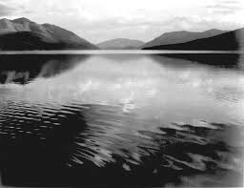
In this image by Adams, this is a true representation of a black and white landscape image in which the only changes have been creating the effect to black and white. In my opinion I feel like the photograph hasn’t got an obvious hidden meaning being shown, although by using the effect of the black and white, it does portray the feeling of eeriness and darkness. One story in which could be behind this image is the fact that it could be showing a dark passed in that area.
Due to the melancholy appearance that the black and white has perceived and created, in my opinion this could be a possible explanation as to why Ansel Adams has used this grayscale effect.
As it is a landscape image it has obviously not been manipulated with the use of a darkroom and extra lighting. Adams has framed his photograph so the mountains seem to move towards the centre of the photo drawing the view to focus on that centre point. By centering the photograph Adam has caused the photo to give a slightly off putting and edgy mood upon the viewer, which could be perceived as uncomfortable and unwelcoming.

In contrast to Adams the work of Charlie Waite uses colour to impact the viewer in possibly a very similar way. Waite is firmly established as one of the world’s leading Landscape photographers, his photographic style is often considered to be unique in that his photographs convey an almost spiritual quality of serenity and calm. Despite the sticking use of saturated colour I find Waite’s images like the one below to evoke an emotion of calm, it could be the way in which he captures a strange stillness the ‘clam before the storm’ while still creating a picturesque landscape reminiscent of those within film and fantasy.
With over 30 books to his name, Charlie's images are recognised around the world. Charlie was recently featured in Amateur Photographer Magazine's series Icons of Modern Photography, and his images have received wide critical acclaim over many years.
In 2000 Charlie was awarded the prestigious honorary fellowship to the British Institute of Professional Photographers and in early 2007 was presented with Amateur Photography’s Power of Photography Award, which is given to a photographer whose work is deemed to effectively demonstrate the powerful and memorable images of which photography is capable. Also a sought after writer, public speaker and television presenter, Charlie has featured in numerous photographic and broadsheet publications, DVDs and television programmes on photography.
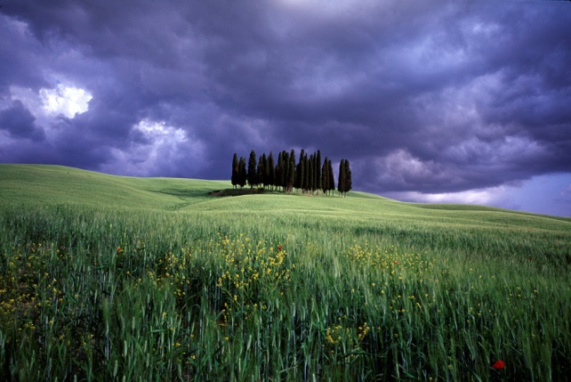
A recent article in Royal West of England Academy Art Magazine featuring Charlie's work commented “Waite’s landscapes are rare perfections of light, colour and composition, and offer the viewer a luxuriant portrait of a planet at peace”.
The image is a true representation of the landscape, however, has been manipulated slightly as the colours have been enhanced to make them more eye-catching and aesthetically pleasing to the viewer. In this image Waite uses an unusually low perspective while centering his subject rather than using the rule of thirds, this immediately creates an image a bold striking image which can make the viewer feel uncomfortable, Waite then manipulates the image by exaggerating the colour leading to the bright unrealistic sickly green of the foreground contrasted to the intense purple/grey of the sky. However despite the fact that on first glance the dark colours can create a more edgy with an almost catastrophic or apocalyptic appearance the overall combined effect of the colours seems to over time become hypnotic and draws the viewer into a calm, tranquil mood.

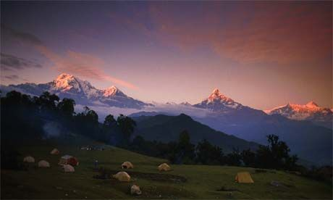
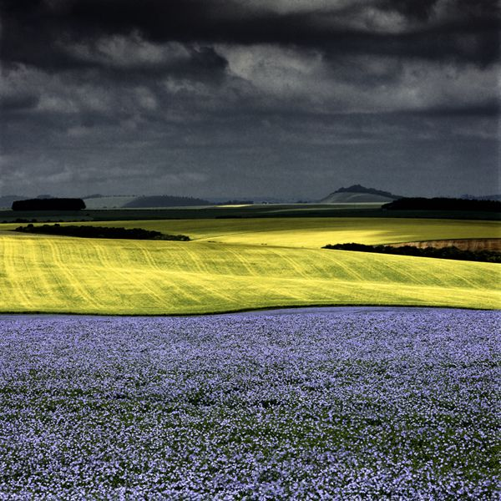

(Galen Rowell) (Charlie Waite)

Similarly to Waite photographer Galen Rowell’s use of colour is prominent through his work. However I feel that in comparison Rowell uses more natural colours in which make his work look more lifelike and in a way more powerful. Although when looking at the composition, subject and lighting the images have many similarities the slight change in the saturation and emphasis on colour can create a distinctly different atmosphere and response from the viewer.

Galen Rowell is a celebrated landscape photographer, who produced a truly inspiring body of work. He is also highly regarded as an author and mountaineer. Born in Oakland, California, in 1940, Rowell had a passion for climbing even as a young boy. The stunning locations in his home state gave him plenty of opportunities for this, and for developing a love of the natural world.
He went on to enrol at the University of California, and spent two years engaged in studying physics. But at that point he decided to drop out - restless to spend more time climbing and enjoying the outdoors. He dabbled in photography, with increasing enthusiasm, and began laying the foundations for a photographic career. He explored the art of landscape photography, portrait photography and still life, all through his own experimentation. Now considered one of the greatest American photographers, Rowell never actually received any formal training.
By 1972 Rowell had become a highly accomplished photographer, and he sold his business to pursue a full time career in photography. In under a year he had completed a cover story for National Geographic Magazine: a photographic journey through the Yosemite National Park in California.
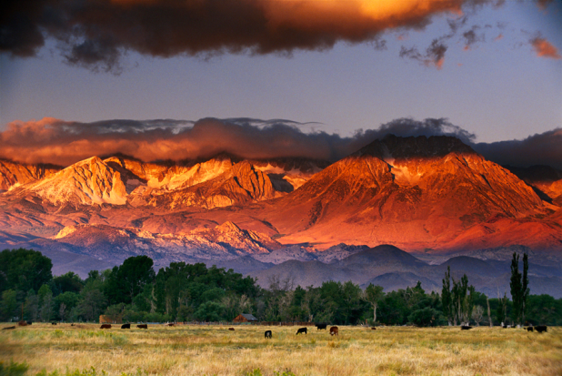

This photograph does not seem to be manipulated in the way that they have changed the picture, although it does look like it has been saturated and the vibrancy and contrast exaggerated to make the bold colours of the mountains stand out more. Galen Rowell work is extremely vibrant and rich in colour; you can see that Rowell has enhanced the images so the colours are more prominent and majestic. In a way this image creates an unnatural atmosphere, which in my opinion sets you on edge but also draws you in the prominent striking red and yellow colours. The comparison between the reds and yellows of the mountains to the greens of the trees make an obvious contrast making the photo more outstanding and eye catching.
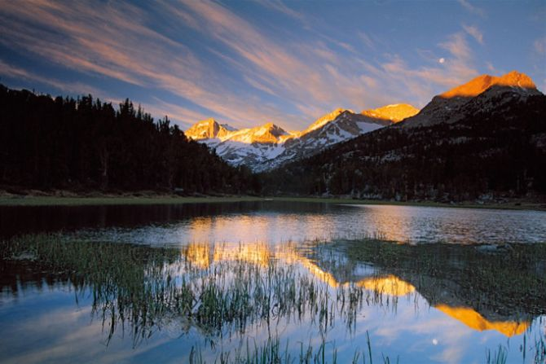
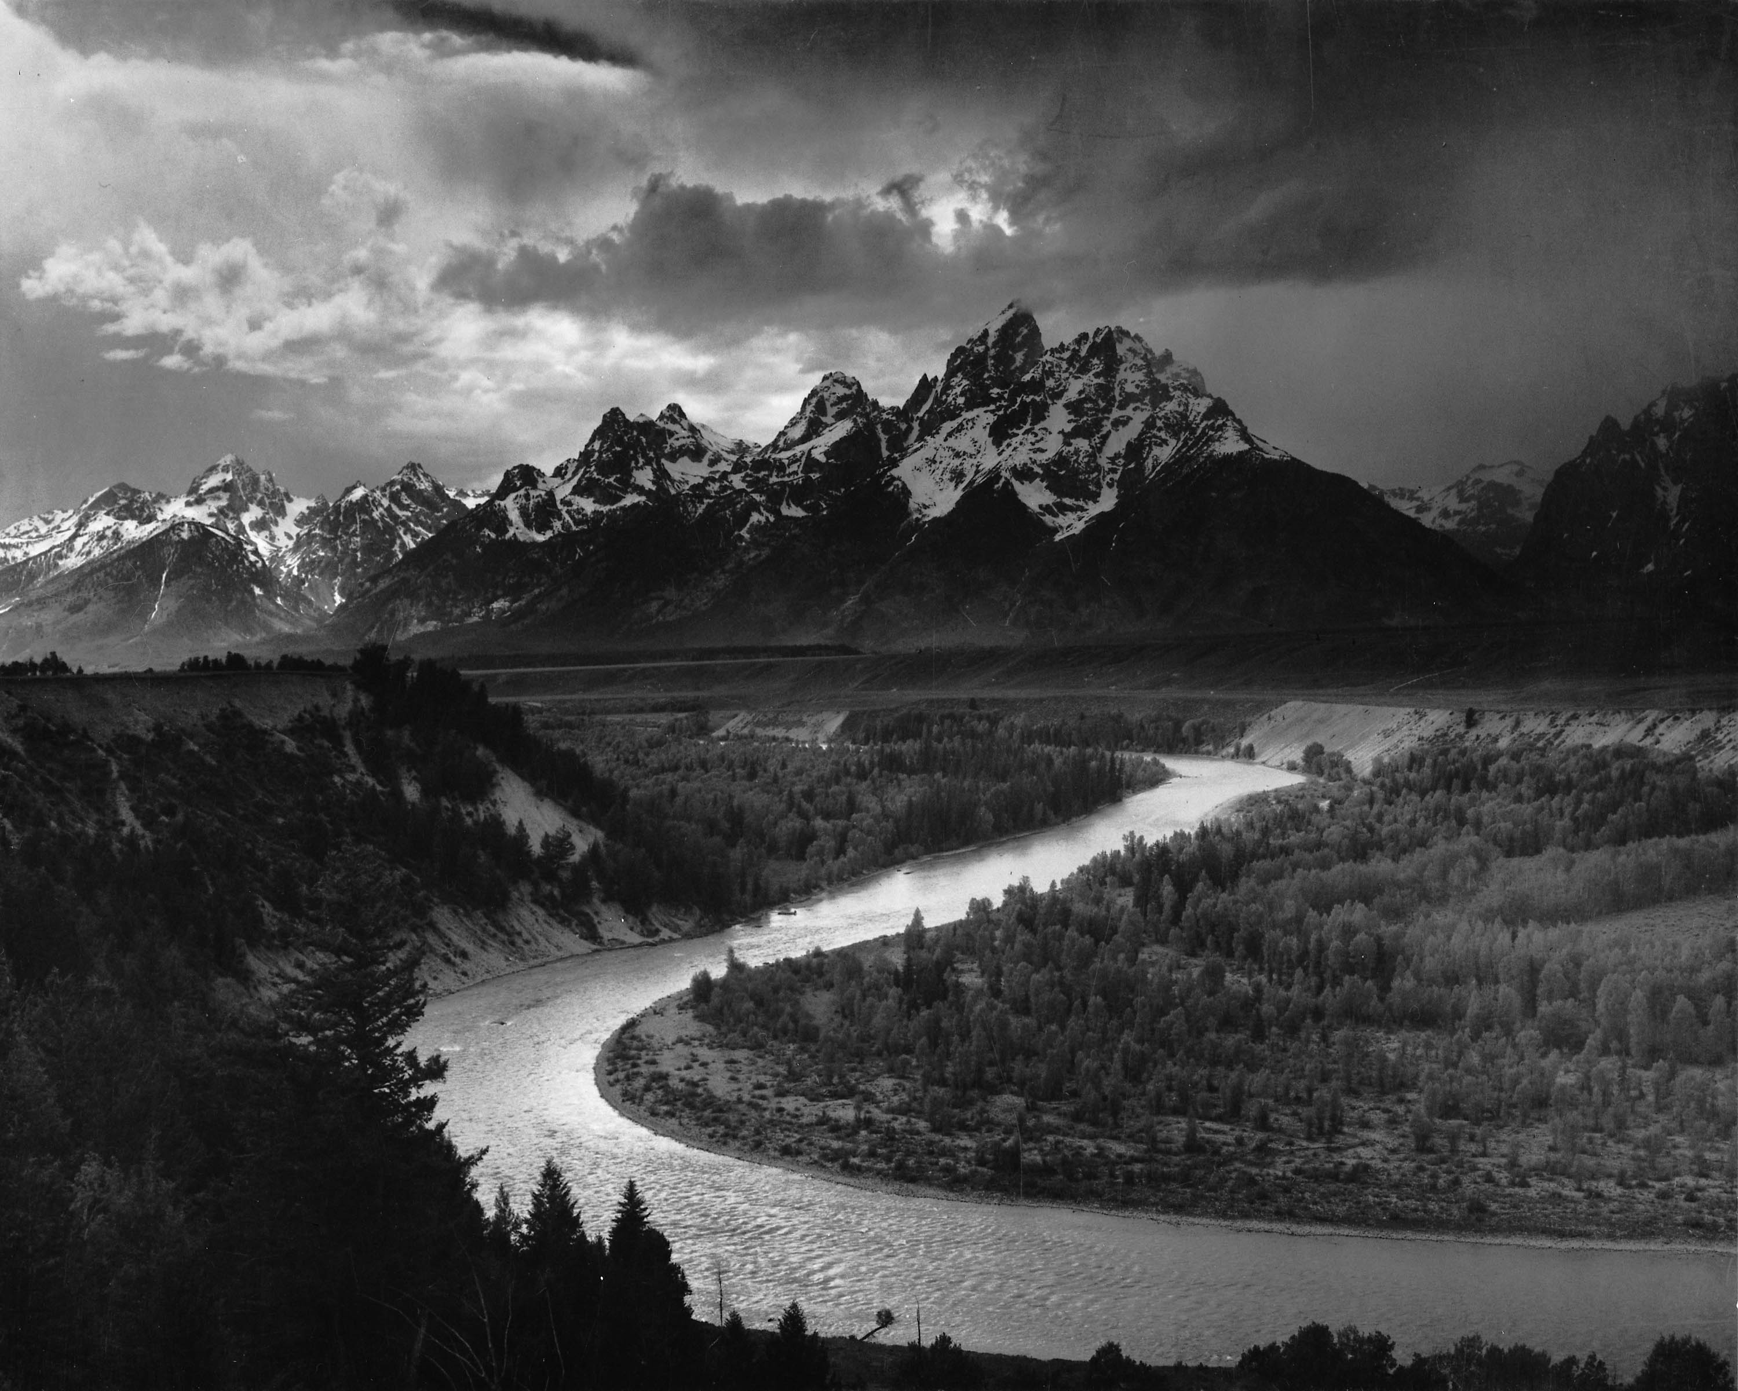

(Ansel Adams) (Charlie Waite)

When compared to the work of Ansel Adams it becomes clear that the use of black-and-white has the ability to changes the whole atmosphere of the image as the lack of colour creates a darker more mysterious feel, rather than warm and inviting imagery of Rowell’s landscapes. The darker tones of the grayscale sky in Adam’s photograph together with the dark high contrast mountainscape evoke an emotion of sadness and loneliness the majestic beauty is to be respected whereas the blue inviting sky in Waite’s photograph together with the warm golden glow of the mountain tops and the familiar green grass of nature create a type of beauty which is inspiring and inviting.

Though this essay I have come to realise just how important colour with the photographic landscape can be as a tool for creating atmosphere and evoking emotion. The use of colour whether subtle, saturated and striking or the shear lack of it is by no means an accident in any image, this vital tool is used precisely and with create emphasise by all of the photographers I have looked at as a means of telling a story, their story the delicate and sometimes fragile and uncertain relationship they have with the landscape they portray. It can be in many ways like looking at a photograph of a loved one or a private emotion shared by the subject and the photographer a special moment which is captured, frozen in time and then shared with the viewer.

References:

www.pearsonhighered.com/assets/hip/us/hip_us_pearsonhighered/samplechapter/0205183468.pdf

http://www.colour-affects.co.uk/psychological-properties-of-colours

http://www.huffingtonpost.com/2011/11/27/how-color-affects-our-moo_n_1114790.html
http://99designs.com/designer-blog/2011/09/08/how-color-impacts-emotions-and-behaviors/
Looking at Ansel Adams – The Photographs and the Man – By Andrea G. Stillman 2012

Seeing Landscapes: The Creative Process behind Great Photographs – By Charlie Waite 1999

Galen Rowell's Inner Game of Outdoor Photography

